**RIT Croatia**

ISTE 240 - Web & Mobile II

*Prof: Ante Poljičak*

**Group Project - A Guide to UNIX**

***by The Tigers for Tux***

**IN THIS DOCUMENT:**

* Analyses of existing guides (on the topic of UNIX & Linux) – *page 2-12*
* Reached conclusion and defined site goals for our project – *page 12-15*
* Selected topics for our sites – *page 15-16*
* Personas – *page 16-17*
* Structure Diagram *– page* *18*
* Moodboards & Styleboards, Logo, Wireframe *– page 19-26*
* About UNIX, About Linux *– page 26-29*
* Linux Installation, Commands, Task Examples, Linux Distros *– page 29-36*
* Operating Systems Comparison *– page 36-38*
* Text Editors *– page 38-40*
* Software Development Modification *– page 40-41*
* Linux Potential, Advanced Commands, Common Errors *– page 42-48*
* File Transfer Protocol, Client-Server Software, LAMP Stack *– page 48-54*
* Essential Apps for Linux *– page 54-56*
* Forum Design *– page 56*
* Sources *– page 57-63*

**RESEARCH** **- Content, Structure & Design**

**Reference I** - *Tutorials Point*

<https://www.tutorialspoint.com/unix/index.htm>

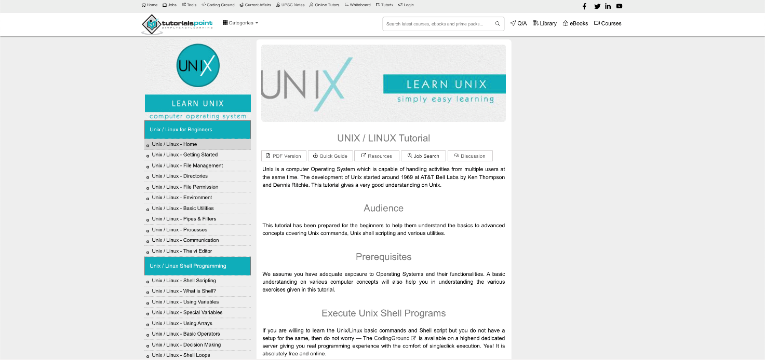

**Content:**

The website offers extensive data on UNIX and its necessary components. It enables the reader to develop an understanding of both the basics of its functionality, as well as the commands needed to utilise it. Header and sub-headers are clear and to the point of their dedicated paragraphs and the entire text is easy to read and follow through. The websites’ goal is to provide readers, with no previous knowledge of UNIX, information about it - its purpose, possibilities and the proper way of handling the operating system. Therefore, as the targeted audience, we would mention beginners, but also those familiar with Operation Systems - users who want to learn and develop smattering or an in depth understanding of the functionalities and possibilities within the UNIX.

**Structure:**

With so much content, the website has a single navigation bar which is on the right side of the screen that guides the reader through the chapters which are available and tells them where they are. The structure fails to provide an easy and quick switch in-between the sub-paragraphs, since scrolling is necessary to reach the top of the site we are currently on. The organisation could improve in how easy it is to access desired commands or explanations without needing to scroll through the entire content of the page we are viewing in the given moment. The greatest flaw is the navigation menu, which is not positioned in a way that leaves it always on display. Scrolling past navigation makes it difficult to reach any other page in this location.

On smaller devices, there is no navigation unless the sidebar icon on the top of the screen is pressed, which is hard to notice because of the very small distance between the search bar, and the user wastes time scrolling back to the top if they fail to notice the navigation bar. Also, the navigation is sticky and is covering a big chunk of the screen which can distract the user. The construction neglects to give a simple and fast switch in the middle of the sub-passages, since looking over is important to arrive at the highest point of the site we are currently on.

The association could work on in the fact that it is so natural to get to wanted orders or clarifications without expecting to look through the whole substance of the page we are seeing in the given moment. The best blemish is the route menu, which isn't situated in such a way that generally leaves it in plain sight. Looking past the route makes it hard to arrive at some other page in this area. On the other hand, header and sub-headers are clear and to the point of their dedicated paragraphs and the entire text is easy to read and follow through. The website in addition to its written content provides videos so that the reader can choose their preferred way of learning.

**Design:**

The site’s design reads “formal” and “librarian”. We can immediately proof-read the front page and understand its goals, as it defines the audience and expectations in terms of prerequisites the given audience would need to satisfy in order to understand and benefit from the content. It does not try to be interactive or engage the reader, rather assumes that the reader is here with a purpose. It is minimalistic and focused entirely on functionality.

The font is easy to read, and the focus is transferred from commands to explanations in a subtle and efficient manner - through fonts, backgrounds, lists, tables, font weight… This site does not try to attract readers who aren’t considered in the expected audience. It is not engaging or interactive, but strictly formal and educational. Where it excels is in splitting the text and organising the viewport. This makes the text easy to read and the commands easier to understand, as syntax is included in separate tables and emphasised on with a different font. The spacing between paragraphs, list items and elements on the page overall is befitting of an informative website.

**Reference II** – *surrey.ac.uk; Teaching Unix*

<http://www.ee.surrey.ac.uk/Teaching/Unix/unixintro.html>

**Content:**

Similarly to the previous website, this page provides a detailed and precise tutorial for the use of UNIX systems. It is written in a way that unambiguously elaborates on everything necessary and is not difficult to read or understand to the common user. Therefore, we could conclude that the targeted audience are beginners who are learning about Unix from scratch - what is its purpose and what are some of the commands and operations that it can do. With simple explanation, the website serves the purpose and the goal in bringing the Unix system closer to its readers and explaining how to use it and successfully execute certain operations in and with it.

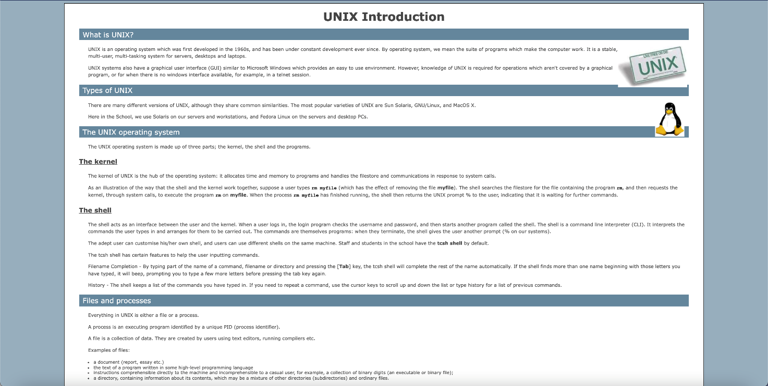

**Structure:**

Unlike the previous example, this website uses barely any CSS. It is written and organised in a precise way, similarly to an exam script (or a cheat sheet). This makes it easy to go through the content A-Z and follow through while learning. What it fails to do, is enable easy navigation.

There is a substantial amount of scrolling required in order for the reader to access any other page and any sub-header or information on the current page. If we are looking for specific information, we rely on the main navigation on the index page, which is the only way user can choose a specific page, after which we need to proof-read the entire content of that page in order to obtain targeted information. It fails to tell the reader where they are at all times. From the page the user chooses, he can only go to the previous page, the next page, or the index page, which has the main navigation. This type of navigation can be distracting for the user and they might not use the page.

On more modest gadgets, there is no route except if the sidebar symbol on the highest point of the screen is squeezed. Although it is a simple design, this website does not include a navigation bar. Having a navigation bar would significantly change the perspective of the website and the user would benefit from it, as well as stay satisfied.

**Design:**

Similarly to the previous website, the design is minimal. The content is well-organised, but fails to deliver an easily readable text at all times. The line spacing could be enhanced in order to allow for an easier and faster scan of the information and the emphasis could be improved (e.g. make examples more noticeable). The site is consistent and splits the content in smaller units which don’t cause the reader to lose interest. The images and changed background of the sub-headers are the sole things breaking the monotony of a plain text document.

**Reference III** – *Stanford.edu; Basic UNIX commands*

<http://mally.stanford.edu/~sr/computing/basic-unix.html>

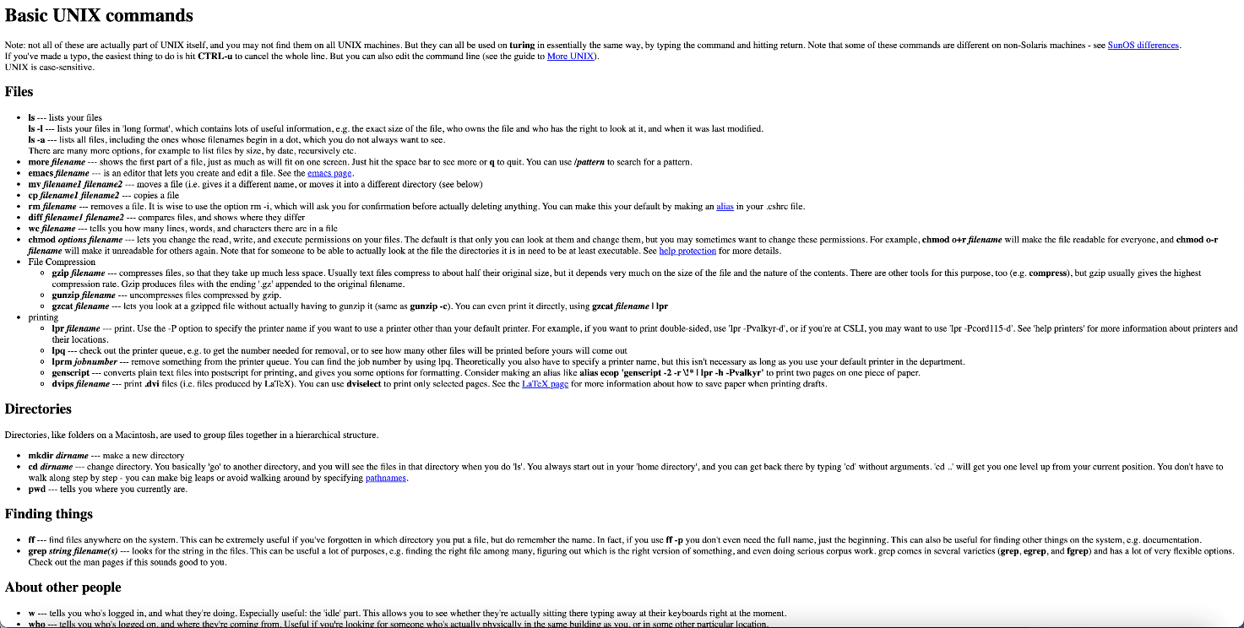

**Content:**

The site is meant to contain basic UNIX commands. It lacks explanations and tutorial-like qualities which would enable understanding of the content at hand. However, to a reader who possesses the necessary knowledge on the matter, the commands would appear clear and well-explained.

Under the “*Note:”* the site mentions possibilities of the commands not working due to certain reasons and with that opens a topic to which they do not offer much explanation, nor an exact solution. As above mentioned, a person that was already in touch with Unix and has some basic knowledge about it could find this website informative and therefore we would conclude that those readers were the initial targeted audience for this website.

**Structure:**

The text fails to provide an easy-to-read site. Navigation is practically non-existent, and the content is placed inside of box-like containers without any additional order or planning. Even if we are looking for a specific basic command, we wouldn’t be able to find it quickly on this site.

The other pages are displayed with links, and the user can't recognise which links lead to other pages, and which lead to other websites. Some websites don't even work, which shows poor work on the navigation side of the website. The websites look almost identical, which can distract the user from finding the important information.

**Design:**

The site uses only HTML. Display is a cluster of text that is not easy to read, and the emphasis is insufficient to provide a faster search. Simple website with little to no CSS design, no navigation bar which makes the design poorly planned/executed, as well as a good amount of text, with little to no guidance through the webpage.

**Reference IV** – *UNIX Tutorial*

<https://www.unixtutorial.org/>

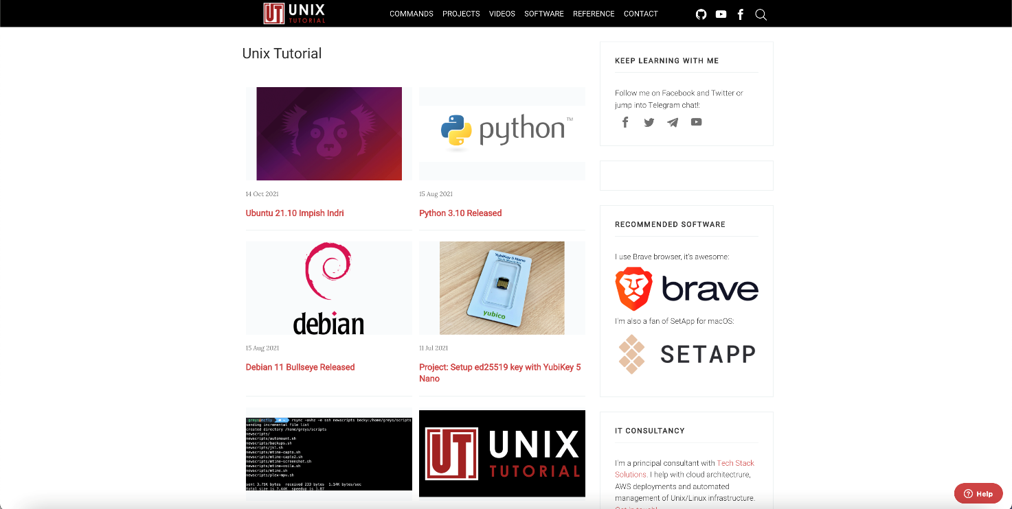

**Content:**

For a tutorial website, it lacks the information necessary for an average user to understand what they are reading. The functionality of the operating system, its purpose and use are not revised in this issue. The commands displayed are written coherently, but lack in explanation. It appears to be a tutorial that “skips the tutorial”. It also lacks examples for the commands that are listed.

To elaborate further, there are no examples where the reader can see how something in the UNIX should be implemented, therefore we would say that this website is targeting users familiar with the UNIX that know what they are searching for while browsing the website.

**Structure:**

Navigation is not visible or accessible from anywhere on the page. The index site doesn’t provide an understanding of the content that can be found here and doesn’t accompany the title of the site. Links that are offered do not appear to fit the “Tutorial” label, since a “common reader” would be lost as to what the projects are even about. In addition, the commands link takes us to a site displaying and explaining the “basic commands for UNIX”.

The first commands page is unnecessary because it doesn't have any important information. The better idea is to put the basic UNIX commands instead, so the user doesn't waste time. The audience was not properly defined, and the site’s goals are unclear. Unlike the previous, this website provides some type of navigation throughout the website, but when scrolling through the content, the navigation doesn't stick to the top of the page, which could very well confuse the user and is hence the biggest flaw of this navigation bar design.

**Design:**

The minimal design fits the informative context of the commands page. Line spacing is sufficient and the usage of lists and sub-headers allows us to browse and/or scan the page quickly, but it fails to place focus on all elements which ought to be emphasised (information of interest). As mentioned, the content is not emphasised and the side bar which consists of articles takes the same attention as the content of the website. Another example of a non-interactive website on desktop or mobile screen.

**Reference V** – *tutorialandexample;* *UNIX Tutorial for Beginners*

https://www.tutorialandexample.com/unix-tutorial/

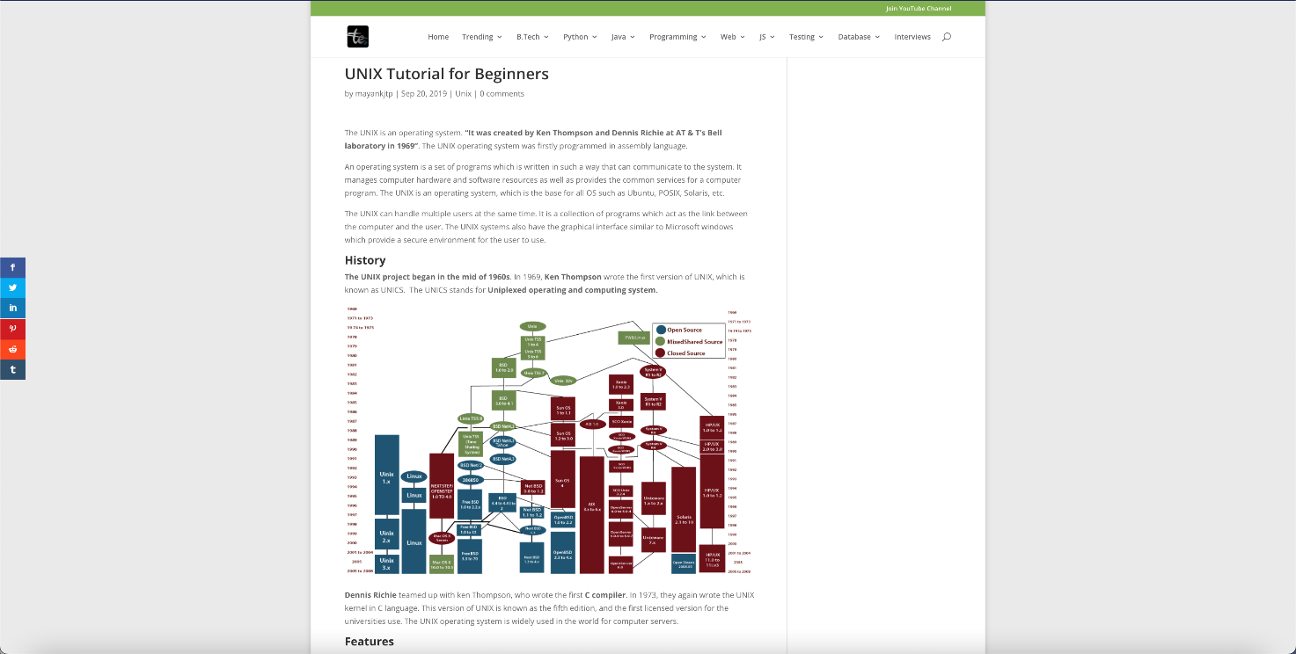

**Content:**

The content is insufficient and random. It attempts to provide a complete overview of UNIX and enable the reader to use and understand it, but it is very shallow on most topics that were mentioned. The choice of commands is not justified and the cluster of screenshots among the textual notes do not make this content coherent, precise or overly useful. An average user would not be capable of using UNIX if they read this tutorial which is composed of seemingly random facts, commands and examples. In terms of an idea or a goal, the website has potential, but it lacks information, and the provided content is written poorly.

**Structure:**

The main navigation bar is the sticky dropdown. The user can easily choose which category or even sub-category he or she wants to visit. Even though the main navigation menu is always easily accessible, there is about 5 pages worth of content in a single page. Due to the lack of a sub-nav menu, it is impossible to go through this extensive amount of content in any other way than scrolling. it is again a cluster of vertically piled block elements. The purpose of the site seems undefined and fails to successfully present its case.

On smaller devices, the navigation bar is too long because of the many subcategories. The better idea was to do it without a dropdown on mobile. On one hand, with a significant amount of content on the landing page, this website's navigation is well designed since it has dropdown menu for more content. On the other hand, mobile users may struggle due to its poor design, as the dropdown menu is substantially long.

**Design:**

Even though the site looks appealing at first glance, the design fails to deliver in terms of maintaining an interest and eluding monotony. The spacing between elements is inconsistent and the dominant elements are not logically set. Lists blend in with paragraphs while the graphics follow examples in the blandest way possible. Some images are nothing but screenshots which are of lesser quality and difficult to read.

**Reference VI** – *cse.msu; UNIX Introduction*

http://www.cse.msu.edu/~cse410/Tutorials/UNIX/unix0.html

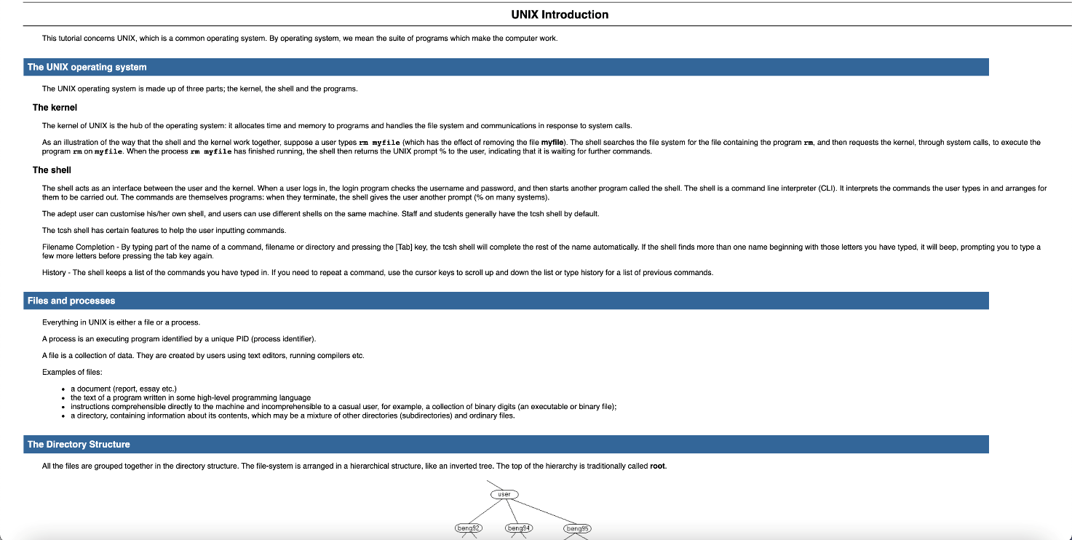

**Content:**

The guide is precise and to the point. It takes the reader step by step through the usage of commands and explains their effects. The introduction is fairly brief and seemingly assumes that the reader already possesses some pre-acquired knowledge of software and computer systems. This tutorial focuses on the practical rather than theoretical and explanatory use of UNIX. The reader may not be capable of explaining to another what is being done, but they would learn the correct procedure and steps in regard to how to perform a certain action. The website lacks examples which would display to the reader how to write the commands properly.

**Structure:**

It is the same CSS as it was in the 2nd example. Lack of easy navigation through the sites is the main issue. The structure makes the content less desirable and harder to read since the paragraphs are long and no adequate layout that would allow readers to quickly scan the information was provided.

**Design:**

Minimal. Focus on functionality. Same as ex. 2.

**Reference VII** – *Arts, Sciences, Engineering; Intermediate UNIX*

http://cng.seas.rochester.edu/CNG/docs/InterUnix.html



**Content:**

The site introduces its readers to UNIX with a substantial amount of information that is provided in enough detail. Commands, examples and definitions are included, as well as the background of the UNIX system. Sub-headers are precise and to the point in their attempt to announce/explain the paragraphs that follow, while the paragraphs themselves are written with precision and are easy to read and understand. The website’s goal is to provide its readers with the needed information and clarification, show possibilities and functions that UNIX offers and how to achieve them.

**Structure:**

The navigation is again not easily accessible and the structure is solely the code that keeps the block elements in a vertical arrangement. Simple website with little to no design structure or navigation usage. With this much content, the navigation bar is necessary as all of the content isn’t easily reachable without scrolling.

**Design:**

Minimal or barely included. The emphasis is achieved through the use of text elements, such as font weight, while the site displays no elements, save from plain text.

**CONCLUSION:**

In terms of content, our website shall provide a similar amount of information and ensure that the audience will acquire a greater understanding of UNIX - its basic functionality, commands, potential and use. The reader will be able to execute basic commands in UNIX and navigate through the system on a “beginner” level.

In addition, it shall provide greater insight needed for more advanced understanding of the operating system and will allow the user to learn more about actions and operations possible later on (once the basics have been mastered). We will aim to provide a “cheat sheet” which would prove itself useful even to more experienced users as they progress in the field or need to be up-to-date with the system. This will stress the commands and actions that can be executed through UNIX and serve as a reminder of the things already learned (and covered by the site).

On top of providing information, we aim to allow our clients to easy understanding of the theory behind the practicalities. They will understand the differences between different systems and be able to recognise potential setbacks and errors on time.

Since it will contain a considerable amount of content (primarily text), the main navigation will always be accessible - whether through “back-to-the-top” buttons (which could prove to be more befitting of smaller screens where we would have a hamburger menu) or sticky/absolute positioning.

In addition to the main navigation which will tell the reader where they currently are and where they can go, it will provide a sub-navigation which will guide them through the page they are currently viewing. That way, the specific commands and definitions will be easy to access.

Interactivity will be achieved through the structure - by creating a responsive layout for different screen sizes. This layout will include a substantial amount of visually engaging and informative content which will fit the graphic design of the site, while also breaking the monotony of purely textual and exclusively information-serving site, as was the case in most sites referenced in this research.

The structure will allow the reader to continue reading more about topics they are interested in and find information they are looking for quickly and easily. It will avoid the “cluster display” by hiding block elements which will contain extensive explanations and/or provide links to other existing pages on the site that deal with the issue at hand in greater detail.

The aim is to keep an interactive level as the primary connection between the home page, which will define the site goals and invite the readers to continue browsing, and the in-depth pages which will provide step-by-step guides and tutorials and contain all the information necessary for them to keep improving their knowledge and understanding of UNIX and its derived systems.

When it comes to design, it will aspire to not only fit the targeted audience, but also attract and awaken an interest in those who are outside of the expected scope, as the design will be more interactive and will look lively.

The images will be informative and befitting of the colour scheme of the site, while also being positioned in a way that does not obstruct the flow of the text, but rather enhances the level of understanding. It will accompany definitions, elaborations and examples with appropriate visuals which will make it easier for the users to track the steps and the procedures of the UNIX system. Aside from its functionality, it will elude bland and monotonous narrative and enable the reader to scan and proof-read the text easily by using appropriate emphasis where necessary, keep an eye on the line-spacing and use of lists, tables, headers and notes.

**SITE GOALS**

This website aims to provide sufficient information for an average user to understand and be capable of utilising the knowledge obtained from the site. In this context, an “average user” represents a viewer with no or very scarce previous experience in computing.

Naturally, users with moderate or sufficient experience will be able to benefit as well, as the site’s navigation shall ensure easy access to targeted data and fast manipulation of links which connect the pages and their content. In addition to being a beginner’s guide, the site will be useful and informative to more advanced and experienced readers.

The users will learn about the origin of UNIX, its use, functions, basic commands and overall potential. They will be guided in terms of what can be done and achieved through the usage of this operating system, its core, its advantages and potential issues (compared to other systems out there), as well as learning the basics behind its commands and operations it executes on an elementary level.

Theoretical aspects shall be extensive enough to provide in-depth understanding of the basics, so that the users will be able to continue building up their knowledge and reach more advanced levels of proficiency. Along with being elaborative and informative, the site shall ambiguously and precisely offer instructions and example of executions of multiple essential commands and tasks.

Finally, it will provide insight in regard to the potential and possible setbacks of the system, while also offering links to exterior sites which would allow the readers to continue learning and perfecting their knowledge.

Additionally, the design will have in mind to attract users outside the scope of targeted audience in being engaging, interactive and visually pleasing, which would make it easier for readers to stay interested (let us call these “analytical pages in short and concise lines). The said analytical pages will be easily accessible and offer in-depth explanations of the materials at hand, their focus shall be on functionality and information.

**RESEARCH – Site Topics**

**UNIX Guide**

**1.** Home Page - briefly about the site and its content

**2.** about UNIX - history and its functionality (insight in kernel and the operating system as a whole) - introduce Linux and continue on “About Linux” page

**3.** About Linux - general overview of the system which introduces the topics covered in the later pages

**4.** How to install Linux

**5.** (UNIX &) Linux commands

**6.** Task examples (UNIX &) Linux

**7.** List and briefly explain distros

**8.** Analyse and compare Linux/UNIX/Microsoft Windows - when is it best to use either/or and what each excels in

**10.** Text editors for Linux

**11.** About software development and modification

**12.** Linux potential

**13.** Further elaborates on potential; examples of advanced operations and commands

**14.** Most common errors/ problems that occur with Linux

**15.** File transfer protocols (focus on Shell)

**16.** Software for accessing online servers (FileZilla)

**17.** Lamp Stack

**18.** Essential Apps for UNIX Users

**19.** Forum Page (review & Q&A)

**20.** Sources

**PERSONAS – Who Is the Guide For?**



Slika na kojoj se prikazuje tekst

Opis je automatski generiran

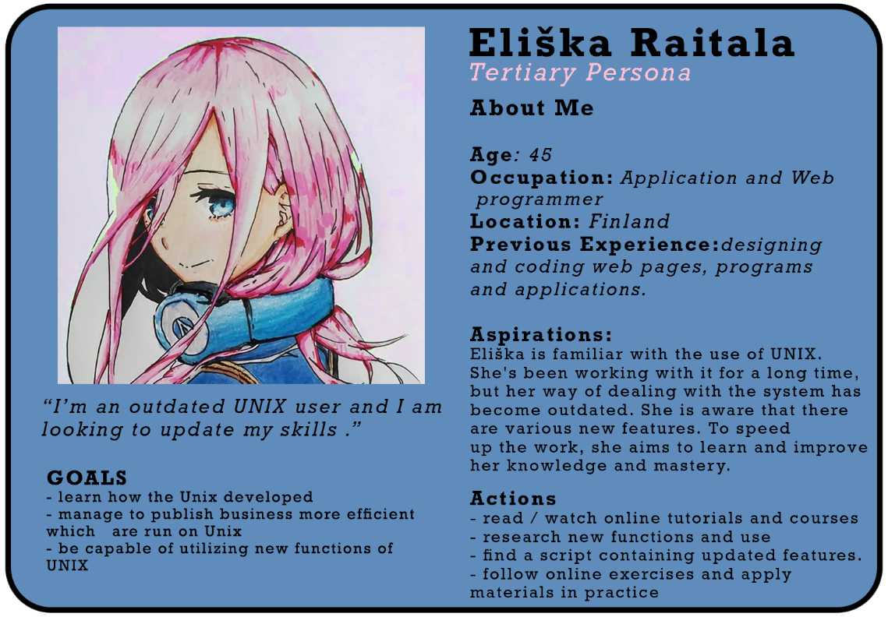

**STRUCTURE DIAGRAM**

The goal is for our site to be consistent and logical. That way, it will enable steady learning, meaning the content we are about to read or one we are being offered to read will expand on what we are currently reading. The basis of such structure is based on hierarchy that is dictated by the content. What shall be the dominant elements on our home page are the two major topics we have chosen to focus on the most – UNIX and Linux. For this, we plan on using what is known as “the parallax scrolling effect”, which will also allow our design to stand out and create an engaging site.

Since this kind of order is more suitable for ambiguous organisation of elements and content, we are keen on creating a hamburger navigation menu which will allow “known-item” searching. This way, the users who are experienced on the matter will be able to reach any site and acquire the needed information very easily and quickly, while those who only started getting familiar with the matter at hand will be able to read through the content in an organised manner. Hyperlinks and buttons will offer additional information in all locations on the site where necessary and allow readers to gain profound understanding if willing.

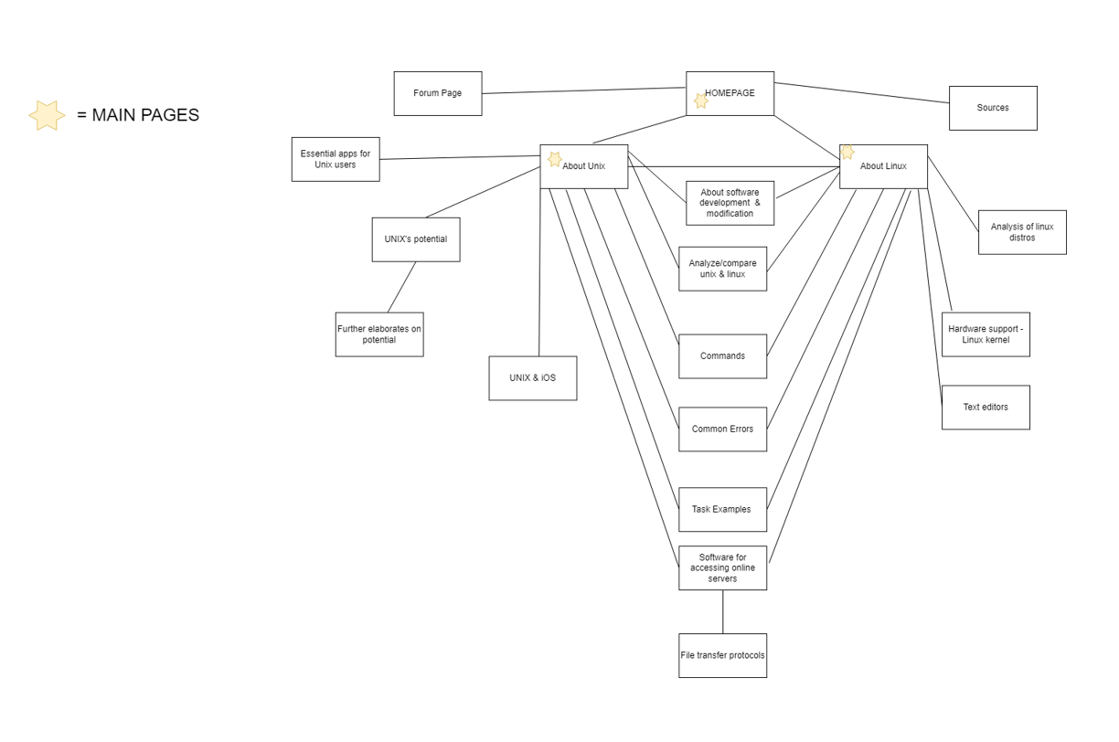

**MOODBOARDS & STYLEBOARDS**





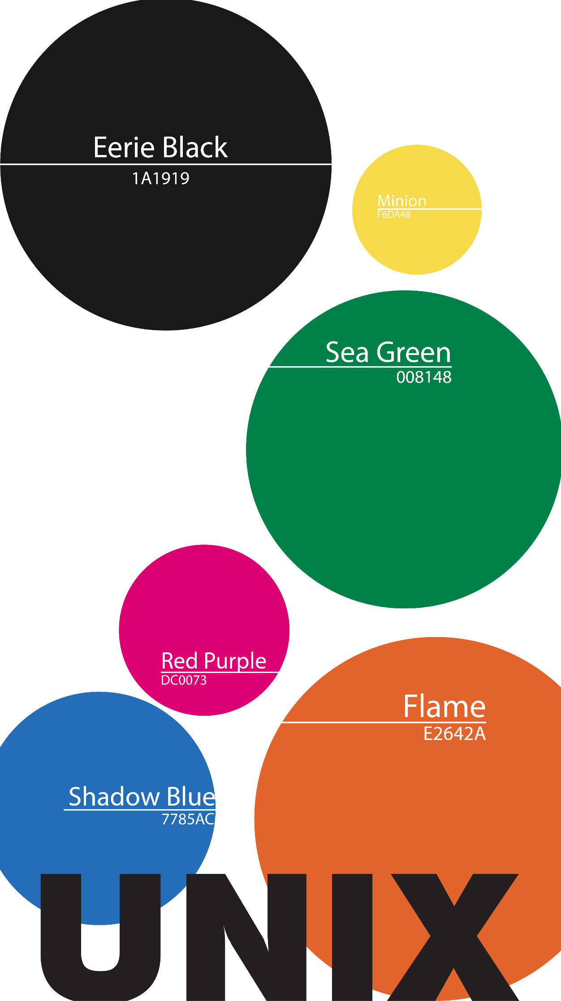





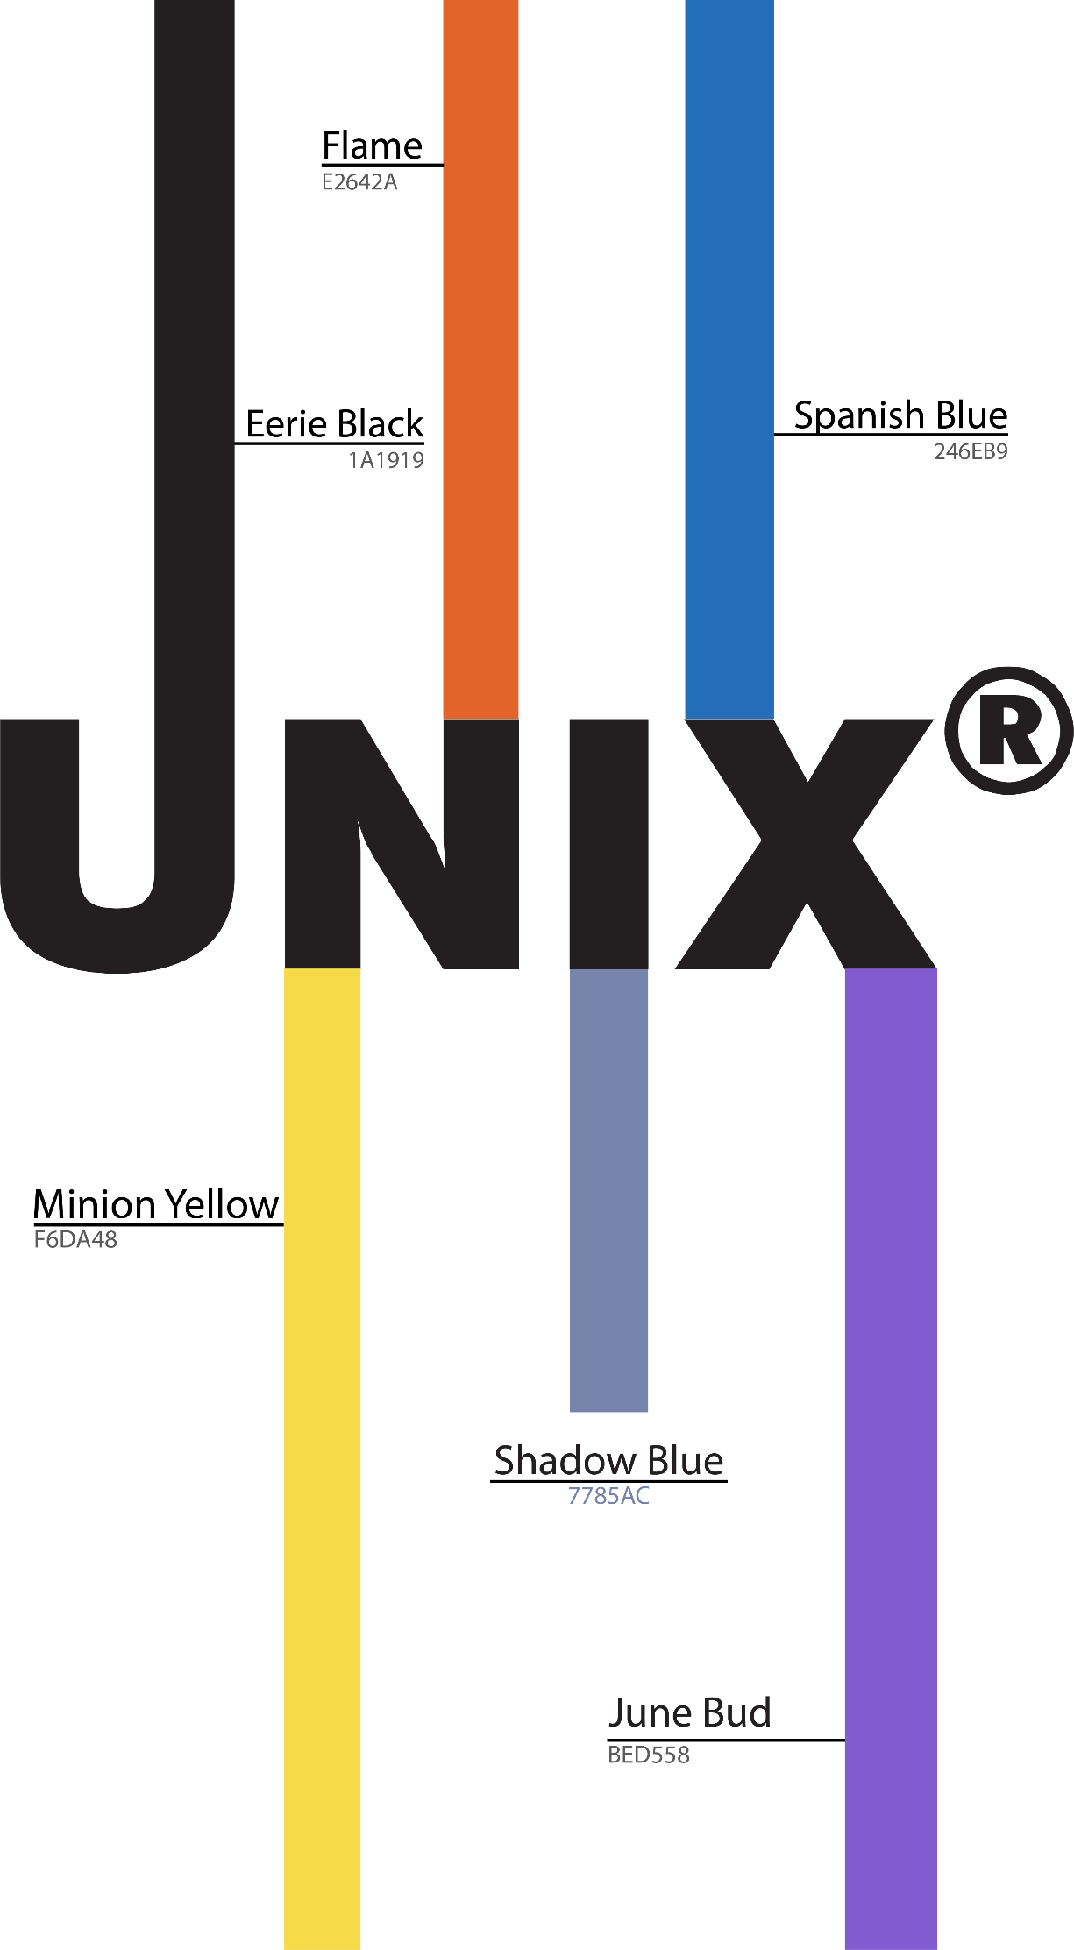

**SITE LOGO**



**Slika na kojoj se prikazuje tamno, svijetlo, noćno nebo

Opis je automatski generiran**

**Slika na kojoj se prikazuje tekst, vektorska grafika

Opis je automatski generiran**

**WIREFRAME**

**Slika na kojoj se prikazuje tekst

Opis je automatski generiran**

**Slika na kojoj se prikazuje tekst

Opis je automatski generiran**

**Slika na kojoj se prikazuje tekst

Opis je automatski generiran**

**ABOUT UNIX**

# What it is?

Unix is a multiuser computer operating system, interface between the user and computer, which manages computer hardware and software resources. It is very known for its simplicity, ability to run on different operating systems, hierarchical file system, and extensive amount of software offerings.

# History

The first version of Unix was developed in 1969 by AT&T Corporation’s Bell Laboratories as a result of the initiative to create a time-sharing computer system. Unix became quickly adapted for other computers and by the end of 1970s the team managed to modify it to the PDP-11. Unix was further developing and new versions of it were created such us Berkeley Software Distribution (BSD) and System V. Today Unix is the basis of Sun Solaris, IBM AIX, and HP-UX. Unix was also used as an inspiration and basis to Mac OS X and open-source operating systems such as Linux and many others.

# Structure of Unix

Unix consists of three main parts: the kernel, the shell, and user commands / applications. The kernel separates the processes and users and regulates the access of system hardware. It also provides an interface to the process, memory, and I/O management. The shell is an interface that reads the command line given and calls the necessary programs to do the work. The command lines given are defined as programs themselves.

# Summary of Unix

As mentioned, Unix is a multiuser and multitasking whole package operating system. It can have more users logged into the system at once where each of them can run many programs parallelly. For Unix it’s also important to know that it can only be used by copyrighters, which means that it’s not freely available to everyone. Unix is used in servers’ workstations and PCs. If any kind of problems occur the users should be aware that they have to wait a certain amount of time that the reported problem gets solved.

# Comparison to Linux

Many people use Unix and Linux as synonyms, although that is not the case. Linux is a clone of Unix, but they still have some core differences. Unix is a whole package operating systems used by copyrighters, where Linux is just a kernel freely available to everyone and developed by sharing and creating codes by the community. Linux gained a bigger popularity than Unix and has a wider usage than the Unix does. When it comes to the file system support and security, Linux showed both higher file support and security. Linux developed a higher demand and nowadays can be seen in many devices that are a part of our lives.

**ABOUT LINUX**

The operating system commonly known as Linux was created in 1991. It is thanks to a Finnish computer science student, Linus Torvalds, that we can use this open-source operating system. Moreover, Linux is the most used open-source operating system today.

This software program oversees simultaneous management of the resources on a computer, such as disk space and computer memory, and enables communication between the computer’s software and hardware. To elaborate further, the core function of Linux is run its own programs which manage the afore mentioned functions and potential devices that are attached to the computer, while also running programs initiated and requested by the user.

Much like UNIX, the core of Linux is “kernel”. It is what powers the Linux operating system. Without it, the computer’s software and hardware would be completely disconnected. As an open-source operating system, Linux uses a type of kernel which is called “Monolithic Kernel”. The tasks of this kernel are to encompass the CPU, memory, IPC, device drivers, file system management, and system server calls, while also being responsible for handing off free system memory to applications.

One of the most distinct differences between open and closed-source is that an open-source project is such a software project which allows access to its source code. To put it simply, every single person who has a computer and access to the internet can access and alter the source code of the Linux operating system if they had such intentions. Therefore, Linux has been modified by many developers since the year of its creation. According to reliable estimations, “nearly 10,000 developers, from more than 1,000 companies have contributed to the Linux kernel”. (Wallen, 2021)

These modified versions of Linux are referred to as distributions, and they include the modifications of the Linux kernel along with other components of the overall system which were made for the users to customise it according to their needs. Some of the major Linux companies that create these distributions are Red Hat, Canonical and SuSE.

Knowledge of the Linux operating system is one of the skills in highest demand on the job market in the IT field today. The number of sources grows continuously and warrants an equal or larger amount of research for one to keep up with all the new distros being created. Once you have decided to learn how to use Linux, a good starting point is where can we access the kernel. As users get more familiar with the commands and processes possible in Linux, they open the doors to many potential applications and systems that rely on Linux in order to operate correctly.

**LINUX INSTALLATION**

The first thing to learn is where can we access the kernel? For this, we can follow J. Wallen’s article (2021) and start with the terminal window. From there, we proceed by issuing the command *ls /boot*, which will display a file called *vmlinuz-VERSION* (where *VERSION* is the release name or number), and the *vmlinuz* file is the bootable Linux kernel (the z indicates the kernel is compressed). Aside from the mentioned file, we will find other important kernel files within that same directory, among which the article specified the following 3;

- ***initrd****:* used as a small RAMdisk that extracts and executes the actual kernel file.

- ***system.map****:* used for memory management, prior to the kernel loading.

- ***config****:* instructs the kernel on what options and modules to load.

The element that requires further argumentation would be the modules. They are necessary for the system to establish communication with the hardware while also keeping the system memory in balance, and they add to the kernel’s functionality. These modules can be managed by the following commands;

- ***lsmod****:* lists all currently loaded kernel modules.

- ***insmod****:* loads a kernel module into the running kernel.

- ***rmmod****:* unloads a module from the running kernel.

A common way to install Linux nowadays is via what is called a “virtual machine” (“VM”) - a computer that is running within another computer that acts as its host. When installing Linux, one ought to choose a distro that best fits the desired usage or consult one of the websites which provide information on the current most popular distributions.

These distros create directories which feature both the kernel and other necessary software and are available for anyone to download. The sole thing one needs is the installer. This will be an ISO file that holds all the installation files, and here the user will most likely be asked to choose between 32-bit and 64-bit distros, so it is important to know the specs of the computer the installation is required on. Once the directory has been downloaded, a bootable installation media will be needed. For this, the user will need the ISO file, a software similar to the Rufus software and a USB drive with enough memory for the selected distro (this is not needed if the booting of the Linux system happens on the same computer the installation files are on).

When launched, the Rufus software will prompt a tab in which the user adjusts the boot selection and chooses the device – in our case, the USB – and browse to the already downloaded ISO file. Once confirmed, Rufus shall erase all the files from the USB and create an installer drive.

Once booted, a “live” Linux desktop shall appear on the screen, but this does not mean Linux has been installed – it is merely running off the USB. This is where the user can try the system and explore its features. Once satisfied, proceed to install it on the computer. It will be installed the same as Windows.

To further follow the guidelines defined by Hess (2021), after installation, the user is prompted to login using the username and password that was created during installation. Upon login, we are placed into our *home* directory inside a shell or operating environment, and that same home directory is a subdirectory of the */home* directory. The Linux filesystem is a hierarchical filesystem, similar to Microsoft Windows, where the root directory is located at the top level and is represented by the “*/* “symbol (Windows uses a drive letter, e.g., *C*: for the root directory).

**COMMANDS**

* ***ls***

shows files/directories in current directory

Directories – blue

Files – white color

*ls -R* (all files not only in directories but it also shows subdirectories)

*ls -al* (shows detailed information of the files)

*ls -a* (shows hidden files)

* ***cat***

Display text files, copying and creating new text files.

1. *cat > filename* (creates text file)

2. Write the content of the text file

3. *Ctrl + d* to exit

4. *cat filename -*  to see the file

*cat file file2 > newfilename* (combines 2 text files, cat newfilename to see the text file)

This command only works for text files.

3. ***rm***

Removes the file.

- *rm filename*

4. ***mv***

Moving the file:

- *mv filename new_file_location*

Renaming the file:

- *mv filename newname*

5. ***sudo***

Allows the user to run programs with the security privileges of another user.

*sudo your_command*

6. ***mkdir***

Creating directory:

*mkdir directoryname* (or *mkdir new_directory_location*)

7. ***rmdir***

Removing directory:

*rmdir directoryname newdirectoryname*

8. ***man***

Reference book of a Linux operating system:

*man mkdir* (shows manual for *mkdir* command)

9. ***history***

Shows all past commands used.

10. ***clear***

Clears the terminal.

11. ***pr***

Used for formatting the files for printing on the terminal

*pr -x filename* (shows content divided in x columns)

*pr -h* *“Header“ filename* (header value is assigned as the header)

*pr -n* *filename* (denotes all the lines in the file with numbers)

12. ***lp, lpr***

Used for printing files

*lp filename (lpr filename)*

Multiple copies

- *10 : lp -n10 filename* (lp 10 testfile)

13. ***apt***

Installing and removing packages:

*sudo apt - get update* (update all installed packages)

*sudo apt - get install packagename* (install packages)

**TASK EXAMPLES**

**Slika na kojoj se prikazuje tekst

Opis je automatski generiran**

Slika na kojoj se prikazuje tekst

Opis je automatski generiran

Slika na kojoj se prikazuje tekst

Opis je automatski generiran

Slika na kojoj se prikazuje tekst

Opis je automatski generiran

**LINUX DISTROS**

As mentioned, the Linux distributions (or “distros”) are modified versions of the Linux software. What is important to note is that these changes are not applied to the fundamentals of the system. In other words, kernel is the core of every Linux distro, the default GNU software which are essentially command-line based utilities remain the same, and finally certain software which are characteristic and greatly used with Linux also remain unaffected by the modifications. This way, you will always have the same web browsers, text editors and similar software available whenever using a device that operates with Linux.

What changes depends on the user and their choice of distros. Certain distributions are updated very frequently and are wide-spread in the community, which offers more general support and help in terms of use. This being said, the quality of distros and its feasibility also varies, since as an open-source software, just about anyone can modify it and create a download package. That being said, the installation is also affected, as it depends precisely on the download package and the source of the distro.

Ultimately, these distributions keep being updated for specific needs and purposes. Some are modified more frequently than others, so when choosing a software you wish to work with, it is advisable to proceed with a widely used one that is “peer-reviewed” in a sense that it is used and reviewed by many Linux users. This would offer frequent updates and user support from a larger community. A list of such distros can be found at [*http://iso.linuxquestions.org/*](http://iso.linuxquestions.org/) .

These are a few of best distros for beginners and short-listed most popular distros.

Distros suitable for beginners:

* *Ubuntu*
* *Fedora*
* *Solus*
* *OpenSuSE*
* *Arch Linux*

Best Distros in 2021:

* *Ubuntu*
* *LinuxMint*
* *Pop!_OS*
* *Zorin OS*
* *Elementary OS*

**OPERATING SYSTEMS COMPARISON**

**Windows**

Microsoft released their first version of their Windows OS in November 1985, with their latest version Windows 11 releasing June 2021 with improvements to UI design, video game support and touchscreen interface.

Windows has highest software compatibility across the most popular OS contenders, with the majority of applications and video games being primarily written for it. The list includes the highly popular Microsoft Office Suite, Adobe Creative Cloud as well as a large portion of video games, with Valve reporting that only 15% of games on their Steam platform support Linux.

**Mac OS**

Mac OS is Apple’s proprietary Operating System for their Desktop and Laptop PC range, with its initial release in 2001. It is part of the UNIX family and as of Version 10.5 Leopard is UNIX 03 certified.

Apple boasts that their Mac OS is great for productivity; whether that be creating documents, editing photos and videos or keeping in contact with friends and colleagues through iMessage and FaceTime.

Mac OS has native compatibility with Apple’s other products such as the iPhone and iPad, allowing calendars, notes, messages and more to be synced across devices allowing the user to always be connected.

**Linux**

Based on the Linux Kernel released by Linus Torvalds in September 1991, there are many distributions of the OS with Ubutunu, CentOS and Fedora being some of the most popular.

While Linux has a small market share for home and office use, the OS is primarily used for servers and embedded systems such as TVs and automobiles, with a 96.4% market share for web servers.

Linux is the primary choice for servers due to it being free, highly scalable and customizable and a highly secure kernel.

**Hardware Requirements:**

|  |  |  |  |
| --- | --- | --- | --- |
| **Minimum Specs** | **Windows (10)** | **OS X (El Capitan)** | **Linux (Ubuntu)** |
| CPU | 1 GHz | X86-64 processor such as Intel Core 2 Duo | 2 GHz |
| RAM | 1GB for 32-bit or 2GB for 64-bit | 8GB | 4GB |
| Disk Space | 16GB for 32-bit or 20GB for 64-bit | 5GB | 25GB |
| Graphics Card | DirectX 9 or later with WDDM 1.0 driver | 512MB | VGA capable |
| Display | 800x600 | 1280 x 1024 | 1024 x 768 |

As there are many different versions of each OS, a selection of popular choices has been used for the above table.

**Market Share:**

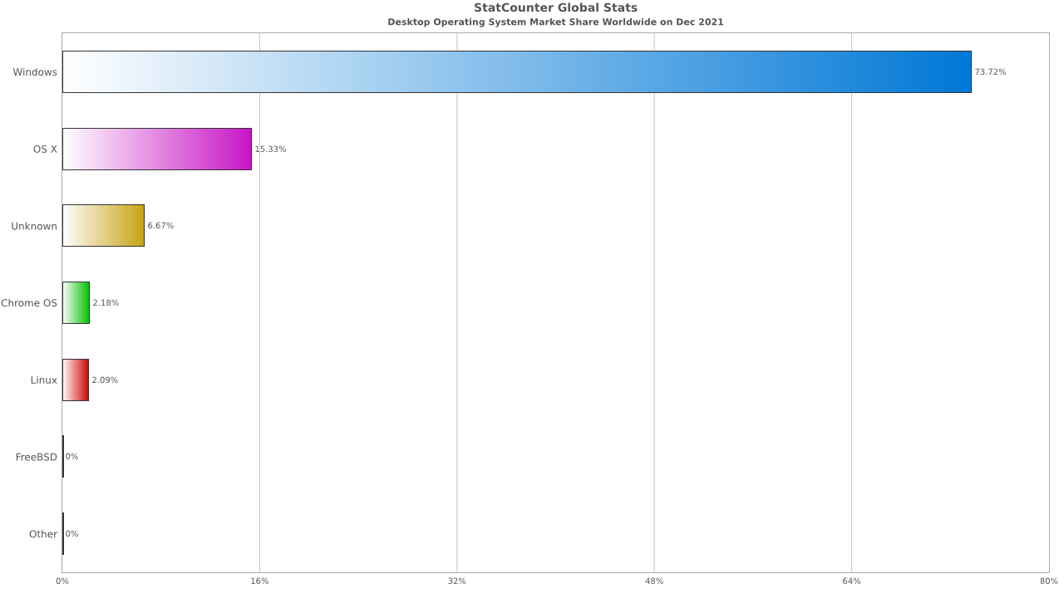

According to StatCounter - Global Stats, as of 2021 Windows has the leading market share with a lead of 73.72% followed by OS X at 15.33% and Linux at 2.09%. A similar trend can also be identified by the Steam, digital gaming marketplace and platform, user hardware survey results.

One of the main reasons behind Windows having such a large share is down to most general-purpose PCs having the OS pre-installed through their OEM partners. This is not the case for the likes of OS X which is only installed and compatible on Apple’s Mac range of computers.

Linux, while free and open-source, has the lowest adoption rate among home users mainly due to it being less user-friendly and not having compatibility with a lot of popular software from Microsoft Office to video games, although in recent years there has been a big push to make more games accessible on Linux through a compatibility layer called Proton developed by Valve Software.

**TEXT EDITORS**

Working with Linux brings forth many software and processes to the user's disposal. The operating system itself features many applications and programs which are almost uniquely found on devices that use the Linux operating system. That being said, the system comes with various text editors needed to execute the commands and perform different tasks.

The command-line interface is therefore mostly mentioned in the same context as command-line text editors. Another “type” of editors would fall under GUI text editor, and both offer a variety of different editors to choose from with new ones being brought to the table frequently to accommodate to the users’ needs. Much like with most thing related to Linux, it depends on the user’s goal and the purpose of the tasks as to which text editor should be picked. The main goal of these programs is to enable easier coding, and therefore maximize the use and efficiency of the system while also making it easier and less time-consuming to use.

This guide will mostly focus on Vim. This is the most used and naturally one of the best-known text editors. It is suitable for beginners and meets most, if not all requirements of users with advanced knowledge and experience. One of the reasons for this reputation is because the editor is supported by most Linux distros, while providing the same working environment regardless of the distribution that is being used. In addition, it was built on the model of the old UNIX Vi editor and modernized to fit the latest updates and features. Two such features are frequently emphasized among users, and those are its ability to highlight the syntax and one called the “Vi modes”. Plainly speaking, this editor has two modes:

- ***Command mode***: enables the user to perform actions on different files and is designed to execute commands (all that is typed here must be part of a command) – this is the mode the user is in when the editor is opened

- ***Insert mode***: enables the user to insert text in files (we switch to this mode by pressing the “*i*” key, to return to command mode, press *Esc*)

It is generally easy to invoke the Vim editor. The user types ***vi <filename>*** to either create a new file, or to edit an already existing one. To save a file, the user must type ***:wq*** to write and quit the file while being in Command mode. The best way to learn how a text editor is used, is to create a new file and try it out for yourself.

Alongside Vim, notable editors are also Nano, Gedit, Sublime text and VSCode. All of these are relatively simple to use due to how straightforward their design and use are, therefore all suitable for beginners and easy to use for experienced users. In terms of traits that make the editor easy to use, most also feature syntax highlighting, undo and redo options and a good command-palette.

That being said, we will single out VSCode, as this has been our starter at RIT Croatia. This is another popular and modern editor that supports a great number of programming languages, has debugging support which includes breakpoints, call stacks and an interactive console. Moreover, the editor also provides the user with a built-in terminal and support for Git commands. These traits make it greatly desirable when programming in Java and similar back-end languages.

In addition to the afore mentioned functionality, the editor also enables parallel coding. This is of great help to front-end developers who work on multiple files and with multiple languages simultaneously. To install the VSCode, users need to download the binary package and execute the following command for Debian and Ubuntu-based systems: ***sudo apt install ./<file>.deb*** .

**SOFTWARE DEVELOPMENT & MODIFICATION**

Software development became important since its included and spread through many devices. It encompasses all actions that result in software products, including research, new development, prototyping, modification, reuse, re-engineering, and maintenance. Software development is the process of generating and maintaining applications, frameworks, and other software components through conceiving, bug resolving, documenting, and testing.

Software development entails writing and maintaining source code, but it also encompasses all activities that lead from the conception of a desired piece of software to its final manifestation, usually in a planned and structured manner.

A set of instructions or programs that tell a computer what to do is called software. Computer programming is possible without depending on hardware.

There are three main types: systems, programming, applications, and software. Operating system, disk management, utilities, hardware management, and other operational needs are all provided by the system software. Programming software includes text editors, compilers, linkers, debuggers, and other tools to help programmers develop their code. Application software is used to help users perform tasks. This includes office productivity suites, data management software, media players, and security software.

The steps in software development process are the following: selecting the methodology, gathering requirements, choosing, and building architecture, developing the designs, and building the model, constructing the code and testing it, managing configuration and defects, deploying and migrating the data, and in the and managing and measuring the project.

Software Modifications are any updates, additions, new versions, enhancements, bug patches, or other changes to the Digital Solutions. To simplify, all changes that result in a modified behavior of the Software.

The process of the software modifications is planned very detailed. The process if as following: firstly, after the modification is planned, a request for the modification is asked. Then the analysis of how the changes will impact the software. The risks are analyzed, and safety modification planned is developed. After that process the process of modifying starts and all changes must be documented. In the end the changes are saved, and the software is modified.

**LINUX POTENTIAL**

To the surprise of many users, Linux is not reserved solely for IT enthusiasts. Since the use and application of Linux can be adjusted depending on the needs of the user, the areas and devices it is being and can be used on extends a lot further than just an average computer. For instance, when it comes down to advanced applications used by governments and major companies, such as Amazon, eBay, PayPal, Walmart, and many others rely on Linux to perform the tasks necessary to enable the highest level of functionality.

In terms of mass use, more than 75% of servers which are used as Cloud solutions also run Linux, all Android devices are actually Linux distributions, and Linux is also the core of the popular Raspberry Pi, Beagle Bone, and many other microcontrollers.

In regard to web development, many servers which can be used to host content, for example bots for specific applications, are in fact using Linux.

Over the past few years, Linux became more popular and widely-used across various different platforms. As a result, the complexity of tasks the users request, be it administrative tasks, configuration management or DevOps workloads has also grown at an equally exponential rate. Therefore, a need has appeared for these tasks to become part of an automated workflow, rather than remaining manual administrative operations, and this is where Linux system comes into play with all its perks and benefits.

The success that Linux as a project faced has inspired many such ideas and projects today, some of which are Samba and GNOME. (*Siever et al. 2009)* Furthermore, it has also become a popular platform for development of Java. Its popularity is also a consequence of the fact that Linux is generally more secure than other operating systems and, when breached, is less vulnerable to widespread damage.

**ADVANCED LINUX COMMANDS**

1 .[***GREP*** Command in Unix](https://fresh2refresh.com/unix-tutorial/advanced-unix-commands/grep-command-unix/)

* + used to determine whether the search criteria are available in the file, and if they are, it prints the matching lines.

2. ***Whoami*** Command in Unix

* + used to identify who is logged into the server (username).

3. ***Passwd*** Command in Unix

* + used to change the password.
  + It will ask for the old password and then prompt you to choose a new one.

4. ***Kill*** Command in Unix

* used to stop an already executing process.
* It is necessary to locate the PID of the process that should be killed and use that PID as the argument.

5. ***Ps -Ef*** Command in Unix

* used to find the PID (Process ID, Unique number of the process) of the process.

6. **ftp** Command in Unix

* used to transfer the files from one server to another server. All you need is the server's name and password.

9. ***Find*** Command in Unix

* used to find the files from the specified directory.

10.***Date*** Command in Unix

* used to know current time in the server.
* current month – ***date +%m***
* current day of month – ***date +%d***
* the year – ***date +%y***
* the hour – ***date +%H***
* the minute – ***date +%M***
* the second – ***date +%S***

12.***Clear*** Command in Unix

* used to clear the screen.
* The current window's content is cleaned, and the cursor is moved to the first line of the window.

14.***Sort*** Command in Unix

* used to arrange the lines of text alphabetically
* ***SORT -N*** :- sorts text into alphabets and numeric lines sorts from low to high value.
* ***SORT -R*** :- sorts text from the files in reverse order.
* ***SORT -F*** :- sorts upper and lowercase texts together.

15. ***Aliases*** Command in Unix

* Used to create a representation for another command.
* the command "clear" could be written as "c" after using ***alias c clear*** command

16. ***Gzip*** Command in Unix

* used to compress files.
* ***gzip filename*** command

17. ***Gunzip*** Command in Unix

* Used for uncompressing files compressed by gzip.
* ***gunzip filename*** command

18. ***Gzcat*** Command in Unix

* Used for looking at a zipped file without actually having to gunzip it.
* ***gzcat filename*** command

**COMMON ERRORS**

Linux driver problems

Try not to hope to track down Linux drivers on the CD that comes with your totally new doohickey. That is not on the grounds that the producers couldn't care less about Linux but since drivers for most gadgets are as of now introduced on your framework as portion modules. Part modules can be stacked from the order line or a startup record, however the HAL/D-BUS framework as a rule perceives equipment and burdens the modules naturally.

Linux wireless networking problems

If there is one topic that causes more detaching from hair than some other, it's remote systems administration, what with in-portion and outsider modules, also the utilization of Windows drivers if all else fails. Then, at that point, you have the different encryption strategies and an assortment of organization the board frameworks to fight with. As with all such things, when you separate it into basic steps, one complex problem turns into a progression of a lot less difficult ones.

Wi-Fi drivers

Generally speaking, Wi-Fi drivers keep on being quite possibly the most problematic technical issues confronting Linux. Many Broadcom remote cards are accessible, and nitty gritty directions for inspiring them to work with every conveyance is very involved for a solitary article, however the essential investigating steps are something similar:

• learn precisely which Broadcom card you have by utilizing *lspci* to figure out the PCI ID,

• decide if the dissemination you use upholds that card,

• also, in the event that it does, recognize the legitimate method for getting the card working.

Printer drivers

Printers additionally keep on being problematic, with Canon and Lexmark more than once referred to for being an issue. Assuming that you're buying another printer, research compatibility before you purchase. Yet, assuming you are moving from another operating system, that may not be a choice. On the off chance that you are doing explore, the 'Open Printing' data set and the authority support channel for your dispersion are the two best places to begin. Note that you ought to guarantee all usefulness of a gadget is completely viable, particularly assuming it's a multifunction item. One normal protest with Canon printers is that the drivers are frequently just accessible on non-English and once in a while dark destination.

Installation

With a category this sweeping, it's nearly guaranteed to be high volume. All things considered; I don't realize that most would agree Linux has wide-spread establishment issues. By far most of introduces go true to form. The sheer assortment of equipment that Linux upholds, and almost limitless blends of equipment on which Linux introduces are endeavored, definitely lead to edge cases to a great extent. Remember that end clients seldom introduce other working frameworks, like Mac OS and Windows, really introduced on new gadgets.

GRUB 2 Boot Loader fails to load

If the hardware is functioning properly, it is possible that the boot loader is corrupted, and Linux cannot start on the machine. In this case, it is necessary to repair the boot loader.

No login or prompt appears

This conduct typically happens after a failed kernel upgrade, and it is known as a kernel alarm on account of the sort of blunder on the framework console that occasionally should be visible at the last phase of the cycle. On the off chance that, truth be told, the machine has quite recently been rebooted following a product update, the quick objective is to reboot it utilizing the old, demonstrated adaptation of the Linux part and related records.

No graphical login

If the machine starts, but does not boot into the graphical login manager, anticipate problems either with the choice of the default *systemd* target or the configuration of the X Window System. To check the current systemd default target run the command *sudo systemctl get-default*. If the value returned is not *graphical.target*, run the command *sudo systemctl isolate graphical.target*. If the graphical login screen starts, log in and start ***YaST › System › Services Manager*** and set the ***Default System Target*** to ***Graphical Interface***. From now on the system should boot into the graphical login screen. If the graphical login screen does not start even if having booted or switched to the graphical target, your desktop or X Window software is probably misconfigured or corrupted.

Login problems

Login problems occur when your machine does boot to the expected welcome screen or login prompt, but refuses to accept the username and password, or accepts them but then does not behave properly.

*Valid username and password not accepted*

This is by far the most common problem users encounter because there are many reasons this can occur. Depending on whether you use local user management and authentication or network authentication, login failures occur for different reasons.

**FILE TRANSFER PROTOCOLS**

FTP or File Transfer Protocol stands for the process of transferring files over a network, which is desirable in larger businesses and companies since it is not necessary to be in the same space in order to share data. This transfer occurs between multiple devices and is triggered by one user allowing another to send or receive files via the Internet. Today, this protocol is used between private parties as well as by websites when uploading files to or downloading from their servers. Simply put, this is a protocol that enables multiple devices and computer systems to send/receive and upload/download files on the internet.

A protocol like this uses Cloud or a similar storage space to save all the files. Instead of Cloud, other secure locations that are held remotely can also be used to store and maintain the data. Therefore, in terms of web development, this is a mandatory protocol for all who aspire to create and/or maintain websites. That being said, most web browsers feature FTP clients which enable the execution of this protocol. To access it, the user will need to log in by using their username and password, after which they will be prompted to access an FTP server through a port number. This can be bypassed by using servers that enable anonymous access to the anyone with internet connection who wishes to transfer files, but using your own credentials is a more secure approach.

After the user has logged in, most software will be easy to use. Straightforward programs like FileZilla are advisable to beginners, while also easy to use for experienced developers. This software is free and easy to download and set up on a computer device. Once installed, the user needs to log in with afore mentioned information and add the address of the server they wish to access. The software establishes a connection and displays all the files stored in the server that user specified. From here, the user controls the transfer of data accessible to them – whether it is to upload, download or modify the files, as long as the permissions are set accordingly.

While this approach is locked behind log in information such as username, password and port number, there is another approach to client-server data transfer.

SFTP or SSH File Transfer Protocol is a secure file transfer protocol which runs over the SSH protocol. Also known as Secure Shell or Secure Socket Shell, SSH is a network protocol which allows its users a secure way to access a computer device when using an unsecured network. This protocol has substituted the afore mentioned FTP, due to its functionality and safety. Mainly, this protocol enables data transfer in a more reliable and secure environment, while also providing easier configuration.

In terms of safety, SFTP is meant to protect against password sniffing and man-in-the-middle attacks, while also protecting the integrity of the data. Unlike FTP, this safe protocol uses encryption and cryptographic hash functions to shield the data, in addition to authenticating both the server and the user. With these traits, in addition to its wide use for establishing secure channels between devices to perform the task of data transfer, SSH is also used to create secure tunnels for other different application protocols. With SSH, the user can also manage routers, operating systems, server hardware and virtualization platforms. SSH connection has been made to ensure many different types of secure communication between a local device and a remote host, including access to resources, remote execution of commands, delivery of new software patches and latest updates, and perform a number of administrative or management tasks. This protocol is accessible to all Unix, Linux and iOS users by default.

To use SSH, the user connects to a remote host for a session within the terminal by ushering the following command to connect to a specific server: ***ssh UserName@SSHserver.***

To perform tasks, the user needs to enter necessary SSH commands. In addition to the command, arguments need to be provided that would direct the software where to go and which directories and storage to target. The following are some of the basic commands necessary for navigation through Shell:

* For ID different from the user’s
  + ***ssh*** [***remote_host_userID@server_name***](mailto:remote_host_userID@server.eg.org)
* List all contents of a directory
  + ***ssh server_name ls***
* Create a new authentication key pair
  + ***ssh-keygen***
* Copy, install and configure a SSH key
  + ***ssh-copy-id***
* Add a key
  + ***ssh-add***
* Program used to copy files from one device to another
  + ***sftp***
* create a new directory
  + ***mkdir***
* create a new file
  + ***touch***
* text editors
  + ***vi/nano***
* clear terminal
  + ***clear***
* download files
  + ***wget***

**CLIENT-SERVER SOFTWARE**

FileZilla Client is a tool used to access server sin order to execute and perform tasks for transferring files to or from a remote computer. This software uses a method known as FTP (File Transfer Protocol). FileZilla is an open-source software, much like Linux, which is easily installed to any computer device that has access to the internet. It runs on Windows, Linux and Mac OS devices, which contributed to its popularity and wide use. This program is a fast and reliable cross-platform FTP, FTPS and SFTP client with a variety of useful features and an easy-to-use user interface. To access a server through FileZilla, the user will need to log in by using their username and password, after which they will be prompted to access an FTP server through a port number.

After the user has logged in, most software will be easy to use. Users connect by entering their username, password, por key number and the address of the server they wish to access. In addition to these features which differentiate it from unsecure software that anyone can anonymously access, this is a straightforward program which is free and easy to download and set up on a computer. The software establishes a connection and displays all the files stored in the server that user specified. From here, the user controls the transfer of data accessible to them – whether it is to upload, download or modify the files, as long as the permissions are set accordingly.

The main display which opens immediately after the log-in has been finalized, includes the menu, tool and Quickconnect bars. Once a connection has been established to a desired FTP site, FileZilla will log the messages, show the local and remote tree view, local and remote site view, transfer queue, and the status bar.

Advanced version of this software, in addition to all free features, also supports a number of protocols, such as FTPS, SFTP and provide Cloud storage options (e.g. Dropbox and Amazon S3). It also provides the queue option for the files meant to be uploaded, copied, downloaded etc. to or from a computer device. This allows its users to see a list of queued files that have not been processed through the specified command, while also displaying failed and successful transfers. This way, it is possible to check the progress of the given task at any moment by merely looking at the window of the program. With this in mind, the file transfer can be prioritized as per the user’s needs and preferences. The files meant to be processed by this program can be specified as “queued” or “immediate”, where queued are the files which are to be processed at a later time, and immediate files are scheduled for an immediate transfer.

To create a new connection, the user opens the “File” menu and proceeds to Site Manager. Here, we select New Site after which we are prompted to enter a title of your website, after which the host’s name is required. All of which is finalized and confirmed with our username and password. Once done, click Connect. After the successful connection has been established, we will see wordpress files to the right of the screen, from where we are able to edit the files.

In addition to aforementioned perks, FileZilla also comes with IPv6 support, tabbed user interface, bookmarks, “drag and drop” support, network configuration wizard, remote file editing option, synchronized directory browsing and HTTP/1.1, SOCKS5 and FTP-Proxy support. The program is available in multiple languages to ensure easy use and a straightforward interface.

To those who wish to explore other similar programs, one of the best alternatives is Midnight Commander. This is another free to use open-source software widely used for data transfer protocols. In addition to this suggestion, there are also other Linux alternatives to FileZilla, such as odrive (Freemium), Snowflake (SSH / SFTP client) (Free, Open Source), ExpanDrive (Paid) and sshfs (Free, Open Source).

**LAMP STACK**

Lamp stack is one of the solution stacks which are designed to create a functional environment for application development. These stacks are composed of sets of individual components which are developed independently in most cases, but due to the fact their usage is oftentimes combined, we may consider them stacks.

As there is a variety of stacks, it is expected for different types to be necessary for different applications. Depending on the tasks a client wants to perform, there exists a variety of stacks that can be used. For instance, if we are to analyse the tasks a developer needs to perform for their work, we can notice multiple tools and programs which are required; an operating system, a web server that’s stores data, database management software, and a programming language which they create a web application in.

The LAMP stack is used to develop and implement web-based applications. Smaller developers can compete with professional software development solutions thanks to its flexibility and efficiency. Each component of LAMP represents a layer of the stack, and when combined, they form database-driven, dynamic websites.

The LAMP term is made up of the initial letters of the component names:

* L as ***Linux*** which is the operating system that runs the rest of the components. It’s a is a popular solution for the LAMP architecture since its open source and easy to customize.
* A as ***Apache*** which is ***the HTTP Server software*** that serves web server static web pages. The web server's job is to handle requests and send information over the internet via HTTP. Modular protocol handling is one of the capabilities supported by the server's modular design. Apache is also recognized for its filters, which are processes that are applied to the data handled by the server.
* M stands for ***MySQL*** which is a relational database management system that may be used to create and manage web databases, as well as data warehousing, application logging, and e-commerce, among other things. Since MySQL is cross platform well-matched it makes it a good solution for LAMP whose goal is to be compatible for more operating systems.
* The last letter P stands for ***PHP***, ***Perl***, and ***Python*** which represent programming languages that are used to create web applications. PHP (Hypertext Preprocessor) combines all of the LAMP stack's components to make webpages and web applications run smoothly. The server runs the PHP commands and provides the results to the visitor's browser when the visitor opens the webpage. Because it interacts nicely with MySQL, it is the fourth layer of the original stack. P also stands for Perl or Python; all three languages are simple but important dynamic tools for generating environments in which applications can be effectively developed.

There are several disadvantages of the LAMP stack, for instance the relational characteristic of MySQL makes the entire LAMP stack less efficient and adaptable than its competitors who utilize non-relational solutions, another disadvantage is the fact that it does not support operating systems other than Linux. Under heavy workloads, Apache can have performance problems, and switching between server-side scripting in Python and PHP and client-side coding in JavaScript can cause development workflow to be disrupted.

Some popular LAMP Stack Alternatives out there that can be used are MEAN, LEMP, LAPP, WAMP, WIMP, and many others.

**ESSENTIAL APPS FOR LINUX**

1. **Thunderbird**

* Free to use email client
* User can add multiple email accounts and database contains settings for all common providers
* Can be enhanced by add-ons such as the Lightning extension which adds a functioning Calendar to Thunderbird

1. **LibreOffice**

* Free office apps
* Writer (word processor), Calc (spreadsheet software), Impress (presentation app) are preinstalled in Ubuntu. Also, there are Draw (vector graphics editor), Math (mathematical formulae composer), Base (database manager)
* Uses ODF (Open Document Format) which can also open Microsoft Office files

1. **Timeshift**

* Used to keep backups of driver updates and configuration changes
* Works similar to the System Restore feature in Windows and the Time Machine tool in Mac OS.

1. **Gparted**

* Best Linux Partition Manager
* Gparted can resize, copy and move partitions without data loss, which can grow or shrink users C: drive, create space for new OS, attempt data rescue from lost partitions

1. **Transmission**

* Free and open-source torrent client
* No pop-up ads
* Uses less CPU than other GUI clients

1. **Sophos**

* Linux Antivirus
* Its supports on-demand scanning and also real-time scanning feature

1. **Open Shot**

* Video editing software
* Modern and simple UI
* Over 800 stylish effects
* Can import and export into any video, audio and photo format

1. **KeePassXC**

* Password manager
* Requires no internet connection
* Cross-Platform
* Open Source

**FORUM**

**Slika na kojoj se prikazuje tekst

Opis je automatski generiran**

**SOURCES**

**AlKabary, A.** (August 2020). Learn Linux Quickly. Birmingham, United Kingdom. Published by Packt Publishing Ltd.  
Reachable at: [*https://learning.oreilly.com/library/view/learn-linux-quickly/9781800566002/*](https://learning.oreilly.com/library/view/learn-linux-quickly/9781800566002/)

**AlternativeTo** (last updated June 23, 2021). FileZilla Alternatives for Linux

Reachable at: <https://alternativeto.net/software/filezilla/?platform=linux>

**Apple, Support** (March 23, 2021). OS X El Capitan - Technical Specifications

Copyright © 2022 Apple Inc. All rights reserved.

Reachable at: <https://support.apple.com/kb/SP728?locale=en_US>

* Why Mac

Reachable at: <https://www.apple.com/uk/mac/why-mac/>

**Both, D.** (2020). Using and Administering Linux: Volume 2. Printed in the United States of America. Published by Apress, Berkeley, CA.

Chapters consulted: Managing Processes (pp 67 - 103), Time and Automation (pp 297 - 324), Security (pp 495 - 543), Backup Everything - Frequently (pp 545 - 564)

Retrieved from: <https://link-springer-com.ezproxy.rit.edu/book/10.1007/978-1-4842-5455-4#toc>

**Bothwick, Neil** (March 08, 2009). TechRadar; Quick fixes for common Linux problems

Reachable at: <https://www.techradar.com/news/software/operating-systems/quick-fixes-for-common-linux-problems-561079>

**Brown, Eric** (March 29, 2019). LinuxGizmos; Linux continues advance in smart TV market

The content on this site is copyright © 2007-2022 LinuxGizmos.com unless otherwise noted.

Reachable at: <https://linuxgizmos.com/linux-continues-advance-in-smart-tv-market/>

**Brent, Mary** (January 7, 2022). Guru99; Basics Linux/Unix Commands with Examples & Syntax (List)

© Copyright - Guru99 2022

Reachable at: <https://www.guru99.com/must-know-linux-commands.html>

**Calcatinge, A., Balog, J.** (June, 2021). Mastering Linux Administration - A comprehensive guide to installing, configuring, and maintaining linux systems in the modern data center. Birmingham, United Kingdom. Published by Packt Publishing Ltd.  
Retrieved from: [*https://learning.oreilly.com/library/view/mastering-linux-administration/9781789954272/cover.xhtml*](https://learning.oreilly.com/library/view/mastering-linux-administration/9781789954272/cover.xhtml)

**Crennan, James** (September 14, 2021). PackageCloud:Blog; 10 most popular Linux distributions, and why they exist

Reachable at: <https://blog.packagecloud.io/10-most-popular-linux-distributions-and-why-they-exist/>

**dani.behzi** (last edited 2021-08-14). Ubuntu Documentation, Installation/SystemRequirements - Installation/SystemRequirements

Reachable at: <https://help.ubuntu.com/community/Installation/SystemRequirements>

**DeNisco Rayome, Alison** (February 16, 2022). CNet; Tech; Windows 11 vs. Windows 10: Major Differences You'll Want to Know

Reachable at: <https://www.cnet.com/tech/computing/windows-11-vs-windows-10/>

**Domantas G.** (Feb 18, 2022). Hostinger Tutorials; Basic SSH Commands That You Should Know About

© 2004-2022 hostinger.com - Premium Web Hosting, Cloud, VPS & Domain Registration Services.

Reachable at: [www.hostinger.com/tutorials/ssh/basic-ssh-commands](http://www.hostinger.com/tutorials/ssh/basic-ssh-commands)

**FileZilla**; The free FTP solution. Overview

Reachable at: <https://filezilla-project.org/>

**FileZilla Pro** – Basic Usage Instructions; How to Update your Blog with FileZilla/FileZilla Pro

© 2018 FileZilla Pro. All Rights Reserved

Reachable at: <https://filezillapro.com/docs/v3/basic-usage-instructions/update-blog-wordpress/>

* FileZilla Pro Supported Protocols

Reachable at: <https://filezillapro.com/docs/v3/basic-usage-instructions/filezilla-pro-supported-protocols/>

* How to Use the Transfer Queue

Reachable at: <https://filezillapro.com/docs/v3/features-v3/transfer-queue/>

**Fresh2Refresh** - Advanced Unix Commands

Reachable at: <https://fresh2refresh.com/unix-tutorial/advanced-unix-commands/>

**HAJIM School of Engineering & Applied Sciences, University of Rochester** - Intermediate UNIX

Reachable at: <http://cng.seas.rochester.edu/CNG/docs/InterUnix.html>

**Hess, K.** (First release: August 31, 2021) Linux System Administration: A Practical Guide to Installation, Configuration, and Management (Early Release). Printed in the United States of America. Published by O’Reilly Media, Inc., 1005 Gravenstein Highway North, Sebastopol.

Retrieved from: <https://learning.oreilly.com/library/view/linux-system-administration/9781098109028/cover.html>

**Hess, Ken** (August 20, 2019). Red Hat; An introduction to the vi editor.

Red Hat, Inc., registered in the United States and other countries.

Reachable at: <https://www.redhat.com/sysadmin/introduction-vi-editor>

**Hoffman, Chris** (Osctober 9, 2020). How-To Geek; How to Install Linux

Reachable at: <https://www.howtogeek.com/693588/how-to-install-linux/>

**http://iso.linuxquestions.org/** - a popular source for technical guidance

**IOWA, Engineering Technology Center** - FileZilla for File Transfer

Reachable at: <https://etc.engineering.uiowa.edu/help-deskcomputer-services-ecs/how-use/filezilla-file-transfer>

**James, Hayden** (January 5, 2022). Blog Linux; Best Linux Distros in 2022 for Beginner, Experienced and Expert users.

Reachable at: <https://haydenjames.io/best-linux-distro/>

**JavaTpoint** (© Copyright 2011-2021). Unix Vs Linux; Difference between Linux and Unix

Reachable at: <https://www.javatpoint.com/unix-vs-linux>

* Linux Text Editors

Reachable at: <https://www.javatpoint.com/linux-text-editors>

**Kili, Aaron** (November 22, 2017). TecMint; 6 Reasons Why Linux is Better than Windows For Servers

Tecmint: Linux Howtos, Tutorials & Guides © 2022. All Rights Reserved.

Reachable at: <https://www.tecmint.com/why-linux-is-better-than-windows-for-servers/>

**Loshin, Peter** (last updated in September 2021). TechTarget; Secure Shell (SSH).

Reachable at: <https://www.techtarget.com/searchsecurity/definition/Secure-Shell>

**Loup, Pierre** (Tue, August 21, 2018). Steam; Introducing a new version of Steam Play

Reachable at: <https://steamcommunity.com/games/221410/announcements/detail/1696055855739350561>

**Magazine Plus by WEN Themes, The Ultimate Newbie Guide**. Chapter 3: Choosing a Linux Distribution, Copyleft ©2019 Alistair Ross. All rights reserved.

Reachable at: <https://linuxnewbieguide.org/overview-of-chapters/chapter-3-choosing-a-linux-distribution/>

**Michigan State University** - Tutorials; UNIX Tutorial for Beginners

Reachable at: <https://www.cse.msu.edu/~cse410/Tutorials/UNIX/>

**Microsoft** - Windows 10 system requirements

© Microsoft 2022

Reachable at: <https://support.microsoft.com/en-us/windows/windows-10-system-requirements-6d4e9a79-66bf-7950-467c-795cf0386715>

**Mitchell, Cory** (updated November 06, 2021), reviewed by Khartit, Khadija, fact checked by Rohrs Schmitt, Kirsten. Investopedia; File Transfer Protocol (FTP).

Investopedia is part of the Dotdash Meredith publishing family.

Reachable at: <https://www.investopedia.com/terms/f/ftp-file-transfer-protocol.asp>

**Pearson.com** (August 18, 2000). Inside the UNIX Kernel

Reachable at: <https://www.pearsonhighered.com/assets/samplechapter/0/1/3/0/0130187062.pdf>

**Pedamkar, Priya** - Linux vs MAC vs Windows

© 2020 - EDUCBA. ALL RIGHTS RESERVED. THE CERTIFICATION NAMES ARE THE TRADEMARKS OF THEIR RESPECTIVE OWNERS.

Reachable at: <https://www.educba.com/linux-vs-mac-vs-windows/>

**Poudel, Diwas** (Nov 7, 2021). OurTechRoom; 19 Reasons Why Windows OS is popular ?

Reachable at: <https://ourtechroom.com/tech/why-windows-os-popular-than-linux-for-desktop-laptop/#:~:text=According%20to%20Statcounter%20of%20Oct,they%20are%20the%20most%20popular>

* What is OEM in Windows ? OEM Windows OS vs Retail Windows OS

Reachable at: <https://ourtechroom.com/tech/oem-in-windows-and-windows-oem-vs-windows-retail/>

**Siever, E., Figgins, S., Love, R., Robbins, A.** (September 2009). Linux in a Nutshell, 6th Edition. Printed in the United States of America. Published by O’Reilly Media, Inc., 1005 Gravenstein Highway North, Sebastopol.

Retrieved from: <https://books.google.hr/books?hl=en&lr=&id=uwNVAgAAQBAJ&oi=fnd&pg=PT6&dq=linux&ots=YJHB6ZEWBe&sig=oC5YyXJiOswyIgitou8J-h2JxgY&redir_esc=y#v=onepage&q=linux&f=false>

**Simic, Sofija** (January 6, 2022). phoenixNAP; What is LAMP Stack?

© 2021 Copyright phoenixNAP | Global IT Services. All Rights Reserved.

Reachable at: <https://phoenixnap.com/kb/what-is-a-lamp-stack>

**SSH Academy** (2021). SFTP File Transfer Protocol - get SFTP client & server; SFTP Server for Linux, Windows, and Mac

© Copyright SSH.COM

Reachable at: <https://www.ssh.com/academy/ssh/sftp>

**Staff Writer from UbuntuPit** (February 25, 2022). Home; Best Linux Software: Our Editorial List of Essential Linux Apps

Reachable at: <https://www.ubuntupit.com/best-linux-software-our-editorial-list-of-essential-linux-apps/>

**Stanford University** - Computing Information for Stanford Linguists, Basic UNIX commands

Reachable at: <http://mally.stanford.edu/~sr/computing/basic-unix.html>

**StatCounter, GlobalStats** (December, 2021). Desktop Operating System Market Share Worldwide

© StatCounter 1999-2022. All rights reserved.

Reachable at: <https://gs.statcounter.com/os-market-share/desktop/worldwide/#monthly-202112-202112-bar>

**SuSE** - 34 Common problems and their solutions

Reachable at: <https://documentation.suse.com/sled/15-SP3/html/SLED-all/cha-trouble.html#sec-trouble-boot>

**The COMET® Program** – Unix Basic Tutorial

Reachable at: <https://www.meted.ucar.edu/ucar/unix/navmenu.php?tab=1&page=2-1-0&type=flash#:~:text=Unix%20is%20made%20up%20of,and%20user%20commands%20and%20applications.&text=The%20kernel%20and%20shell%20are,memory%20allocation%20and%20file%20storage>

**The Editors of Encyclopaedia Britannica** (last updated by Erik Gregersen). Encyclopaedia Britannica; UNIX Operating System  
**- Hemmendinger, David** (Feb 18, 2022). Encyclopaedia Britannica; operating system (OS)

Reachable at: <https://www.britannica.com/technology/operating-system>

**The Open Group** – UNIX 03

UNIX® is a registered trademark and the Open ‘O’ logo and The Open Group Certification Mark are trademarks of The Open Group.

Copyright © The Open Group, All Rights Reserved

Reachable at: <https://www.opengroup.org/openbrand/register/brand3555.htm>

**Tirthakar, Swapnil** (2021). Best of Linux; Best Linux Distros for 2022. Linux Hint LLC, [editor@linuxhint.com](mailto:editor@linuxhint.com). 1210 Kelly Park Cir, Morgan Hill, CA 95037.

Reachable at: <https://linuxhint.com/best-linux-distros-2022/>

**Tutorial and Example** (2019-09-20, 11:34:47). UNIX Tutorial for Beginners

Reachable at: <https://www.tutorialandexample.com/unix-tutorial>

**TutorialsPoint, Simply Easy Learning** – Learn Unix; Computer Operating System; Unix/Linux for Beginners

Reachable at: <https://www.tutorialspoint.com/unix/unix-getting-started.htm>

**University of Surrey** - UNIX Tutorial for Beginners; Introduction to the UNIX Operating System; UNIX Introduction

Reachable at: <http://www.ee.surrey.ac.uk/Teaching/Unix/>

**UnixTutorial** – Basic Unix Commands, Linux Commands, Unix Reference

Reachable at: <https://www.unixtutorial.org/>

**W3Cook** - OS Market Share and Usage Trends

© Copyright W3Cook, All Rights Reserved

Reachable at: <https://web.archive.org/web/20150806093859/http:/www.w3cook.com/os/summary/>

**Wallen, Jack** (October 18, 2021). Lifewire - heck for Humans; What is the Linux Kernel?

Reachable at: <https://www.lifewire.com/what-is-linux-kernel-4173647>

**Wen, Alan** (July 16, 2021). NME; News; Gaming News; Half of Steam’s most popular games may not run on Steam Deck

Reachable at: <https://www.nme.com/news/gaming-news/half-of-steams-most-popular-games-may-not-run-on-steam-deck-2995562>

**www.distrowatch.com** - a website dedicated to the Linux distributions

**You Can Learn** (Jan 7, 2019). Introduction to UNIX

Reachable at: <https://www.youtube.com/watch?v=5Q_IkMdiRJQ>